**Third assignment**

**Exercise I**

The board of directors of Tarbell Industries consists of eight men and four women. A four member search committee is to be chosen at random to conduct a nation wide search for a new company president.

(a) What is the probability all four members of the search committee will be women?

(b) What is the probability all four members will be men?

(c) Does the sum of the probabilities for the events described in parts (a) and (b) equal 1?

Explain.

**Exercise II**

A sample of executives were surveyed about loyalty to their company. One of the questions was, “If you were given an offer by another company equal to or slightly better than your present position, would you remain with the company or take the other position?” The responses of the 200 executives in the survey were cross-classified with their length of service with the company.

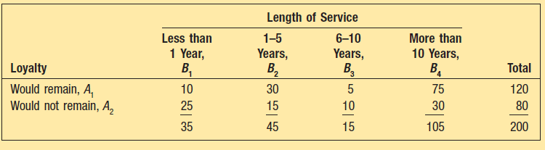

(a) What is the probability of selecting an executive with more than 10 years of service?

(b) What is the probability of selecting an executive who would not remain with the company, given that he or she has more than 10 years of service?

(c) What is the probability of selecting an executive with more than 10 years of service or one who would not remain with the company?

**Exercise III**

A sample of students attending Southeast Florida University is asked the number of social activities in which they participated last week. The chart below was prepared from the sample data.

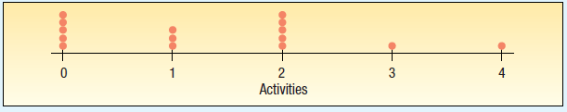

**a.** What is the name given to this chart?

**b.** How many students were in the study?

**c.** How many students reported attending no social activities?

**Exercise IV**

McGivern Jewelers is located in the Levis Square Mall just south of Toledo, Ohio. Recently it ran an advertisement in the local newspaper reporting the shape, size, price, and cut grade for 33 of its diamonds currently in stock. The information is reported below.

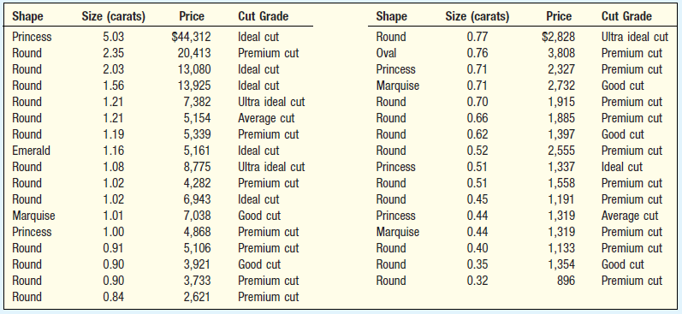

**a.** Develop a box plot of the variable price and comment on the result. Are there any outliers?

What is the median price? What is the value of the first and the third quartile?

**b.** Develop a box plot of the variable size and comment on the result. Are there any outliers?

What is the median price? What is the value of the first and the third quartile?

**Exercise V**

Consumers were surveyed on the relative number of visits to a Sears store (often, occasional, and never) and if the store was located in an enclosed mall (yes and no). When variables are measured nominally, such as these data, the results are usually summarized in a contingency table.

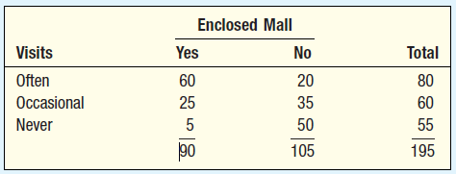

(a) Are the number of visits and enclosed mall variables independent? Why? Interpret your conclusion.

(b) Draw a tree diagram and determine the joint probabilities.